Programming Home Task 3

By Faizan Ahmad (476602)

Task 1

Write a C++ program to print the total number of populations in Punjab, Sindh, KPK, and Baluchistan using a switch case.

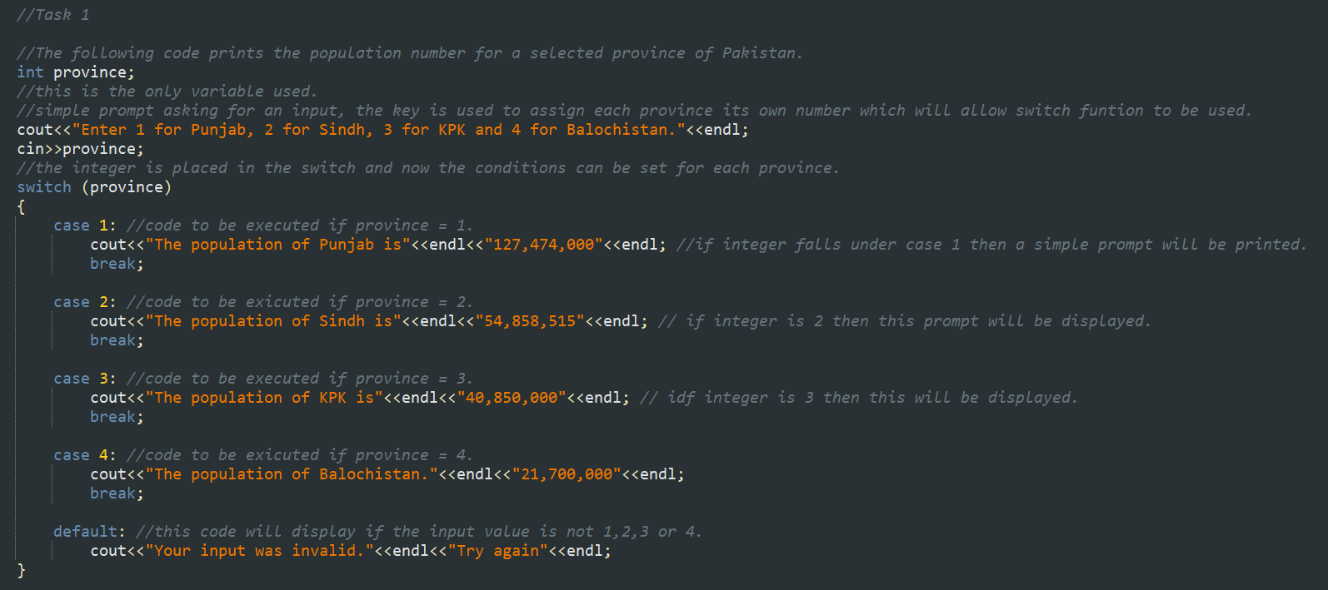

For this task I first made a key that represents each province as a number, then I used the switch function to make cases for each province number. I then set the default to be an error prompt that shows up if none of the cases match.

Task 2

Write a C++ program to check whether an alphabet is a vowel or consonant using a switch case.

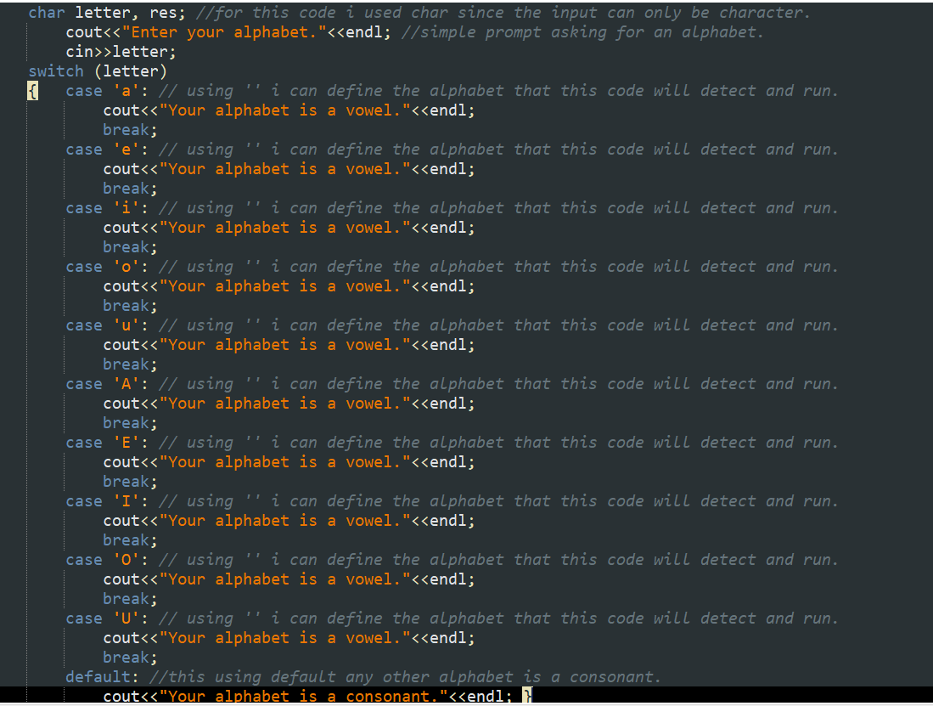

For this code I first used char to define any letter, then using a long list of cases I set the switch for every lowercase alphabet and for all uppercase alphabets. The default was set to out put “Your alphabet is a consonant” because if any letter does not pass any of the cases then it must be a consonant.

Task 3

Write a C++ program to check whether a number is positive, negative, or zero using a switch case.

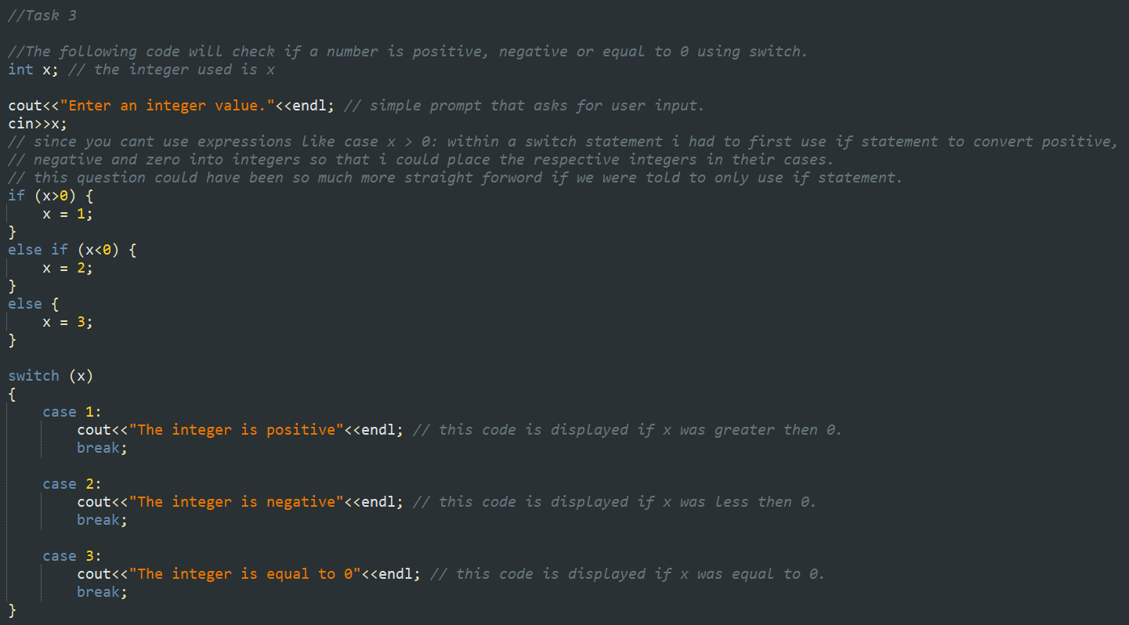

For this code I used int as switch mainly works on whole numbers, I first used if-else statements to convert my inputs into 3 categories i-e x>0, x<0 and x=0. This allows me to use cases to determine the output. This code is complicated since you cant put equations in cases.

Task 4

Write a C++ to find out whether a person is an adult, teenager, or child using nested if-else.

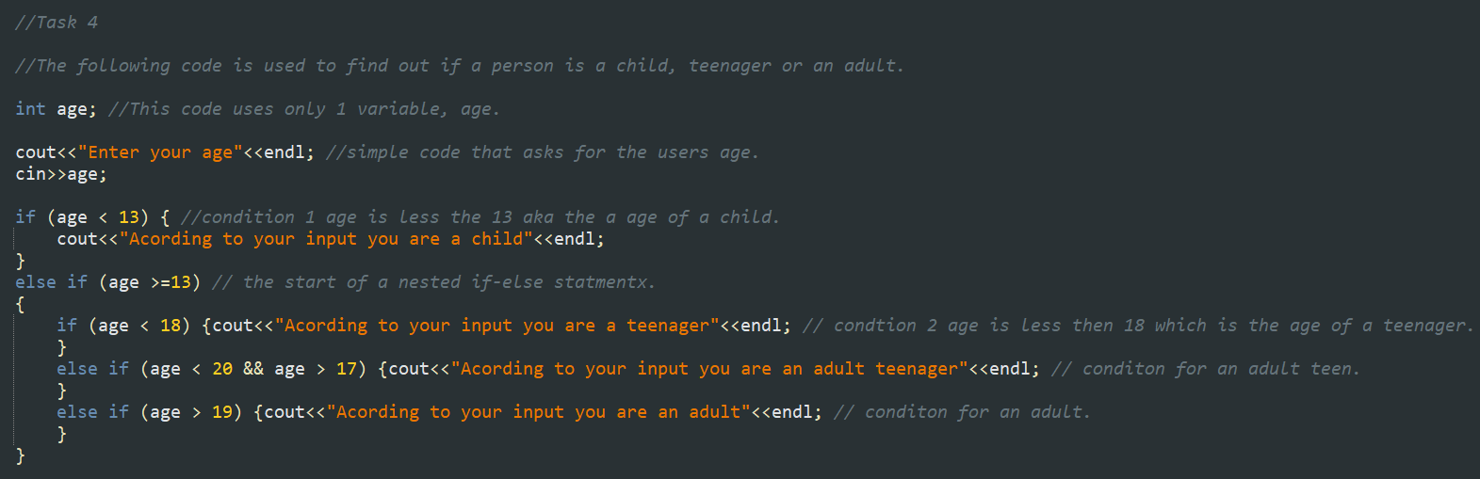

For this task I set my first if as greater less then 13, then using nested if-else I coded the rest of the possibilities. I also added an output for an adult teenager as when someone is both 18+ but less then 20 they can be considered an adult teenager.

Task 5

Write a C++ program that takes three number from the user and find the greatest number out of the three numbers using nested if-else statements.

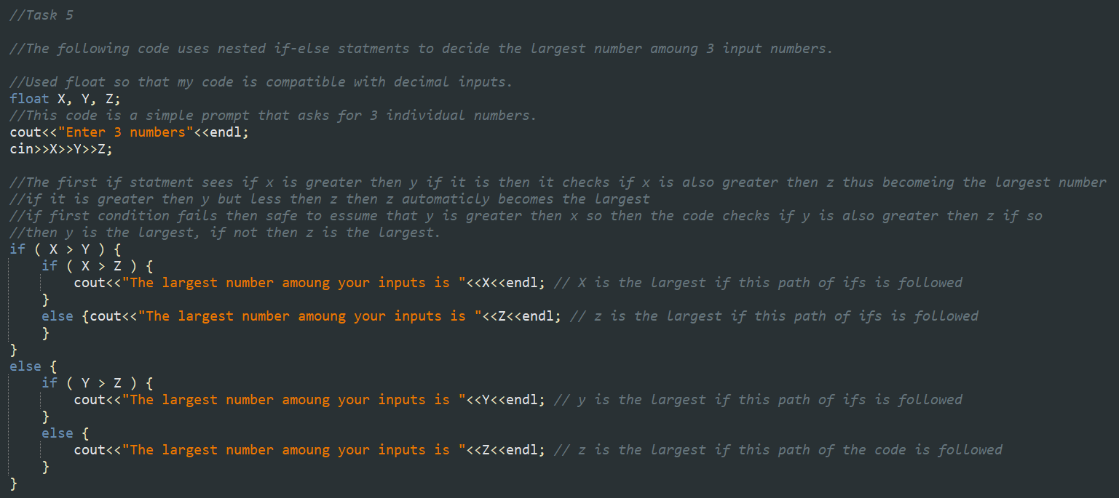

For this task I used float in order to be able to use decimal values, then I set the first if as X>Y and if this is true then the a nested if X>Z which if true would mean X is the largest, if not then automatically Z is the greatest. If the first condition fails then that mean Y>X so then the next nested if is Y>Z which if true mean Y is the largest and if false then automatically Z is the largest.

Task 6

Write a C++ program to check whether the alphabet entered by the user is Vowel or Consonant using nested if-else.

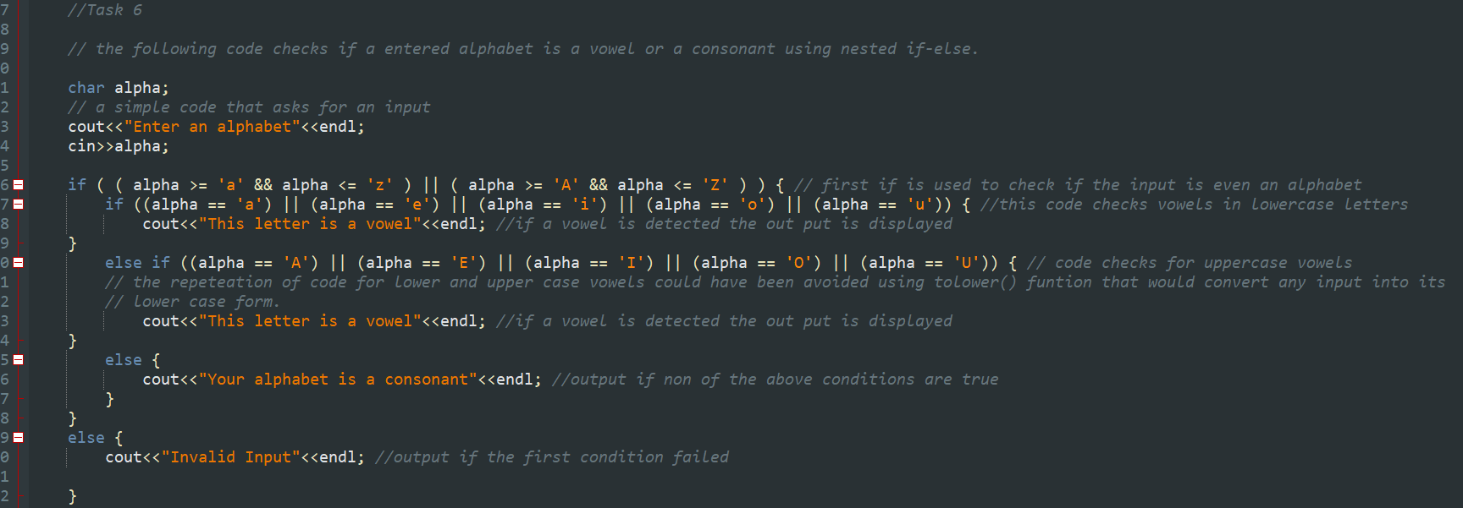

For this task I used char to define the input, then I used the first if to check weather the input is even an alphabet. Then I used a nested if-else statement to check if the alphabet is a vowel of not. If the first if fails then the input mast have not been an alphabet so an error prompt appears.

Task 1-6 Outputs:

